

|  |  |  |
| --- | --- | --- |
| Course Name: Information and Communication Technologies Lab Code: CEN1005 | | |
| LAB #1: Computer System vs Raspberry Pi vs Micro-controller unit board | | |
| **Department** | **Registration Number/Name** | **Semester/Section** |
| BS CEN | F24604018/Muhammad Hamzah Iqbal | 1 |
| **Date** | **Instructor’s Name** | **Instructor’s Signature** |
| 20/09/2024 | Iqra Ashraf |  |

**Objectives:**

* **To understand basic computer hardware parts. Raspberry pi and Micro-controller unit boards.**
* **To identify placement of different components of computer hardware, Raspberry pi and Micro-controller unit boards.**
* **To write observation.**

**Introduction:**

In this Lab we have learned what components a computer contains. In addition to this we have studied Raspberry Pi and Arduino and how they are different. Arduino can perform simple projects such as sensors, motors and other beginner tasks whereas raspberry Pi is able to run complex programs, multimedia and networking. Furthermore, we have also been introduced to microcontrollers and microprocessors which are used in all embedded systems. We learned how microcontrollers contain a CPU (central processing unit), memory and Input and output but microprocessors only have a CPU. This basic knowledge has helped us better understand how different parts of a computer work together.

**Tasks:**

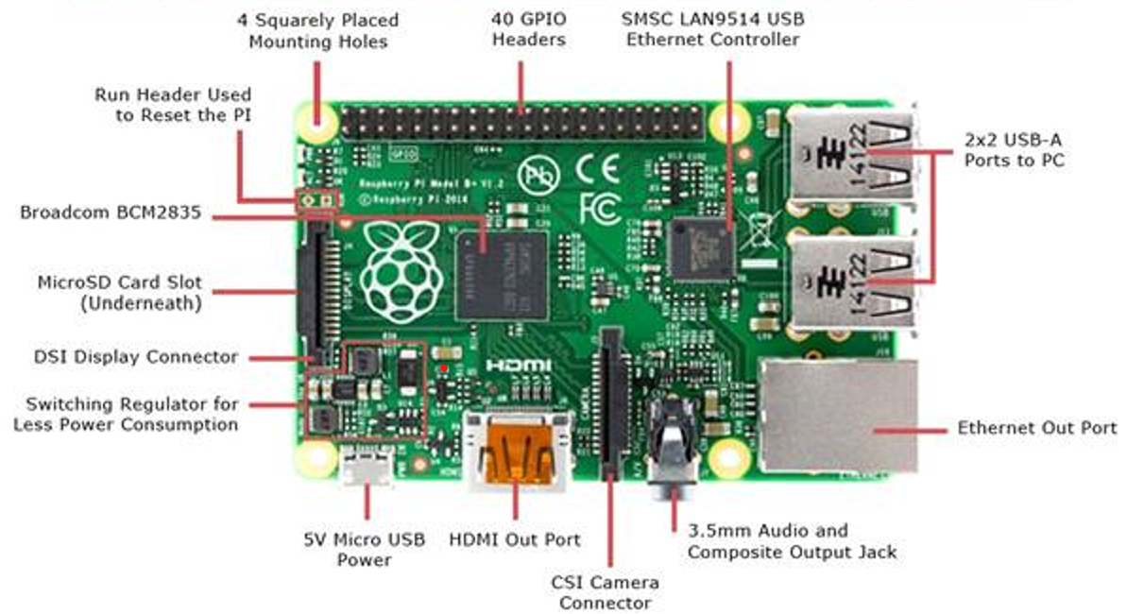

**Question 1: In the above give Raspberry Pi module, study the mounted components and write a detailed report on their function?**

Raspberry Pi can be described as a Single board computer that can be connected to desktop and controlled using a mouse and a keyboard. It can run both Windows and Linux but preferably it has its own operating system know as Raspberry Pi OS which is a modified version of Linux. The components it contains are expressed in detail below:

**Broadcom BCM2835**: This can be assumed as the brain of Raspberry Pi and it contains,

* **Central Processing Unit (CPU)**: Handles the main processing tasks, running the operating system and applications.
* **Graphics Processing Unit (GPU)**: Manages graphics and video processing, enabling display output and multimedia functions.
* **Memory Controllers**: Interfaces with the RAM to manage data storage and retrieval.
* **Peripheral Interfaces**: Includes controllers for various connections like USB, HDMI, and GPIO (General Purpose Input/Output) pin

**Micro SD card:** The SD card slot in a Raspberry Pi is used to store the operating system, which the device loads to start up. It also holds all your files and programs, acting as the main storage for the device. Essentially, the SD card is crucial for both booting up the Raspberry Pi and saving your data and applications.

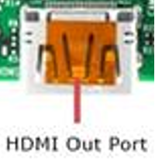

The **HDMI port** on a Raspberry Pi connects the device to external displays, such as monitors or TVs. This is essential for interacting with the Pi watching media.

The **CSI camera connector** on a Raspberry Pi allows you to connect a camera directly to the board. This provides high-speed data transfer for capturing high-quality images and videos.

The **Ethernet port** on a Raspberry Pi connects it to a wired network for internet access and communication with other devices. It provides a stable and fast connection compared to wireless options.

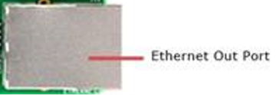

The **SMSC LAN9514 chip** on a Raspberry Pi provides USB-to-Ethernet connectivity, enabling wired network access through a USB port. It handles the conversion between USB and Ethernet signals for reliable internet and network connections.

The **two USB ports** on a Raspberry Pi allow you to connect external devices like keyboards, Mouse, and storage drives. They enable easy connectivity and data transfer to enhance the Pi's functionality.

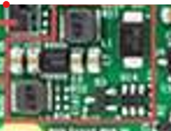

**Switching regulator** efficiently controls the power from the source, converting it to the right voltage needed for the device. This helps prevent energy waste and keeps the Pi running smoothly without overheating, which is important for stable performance.

**Run header** is used to reset Raspberry Pi with some set of commands that reboots the device and restores its default settings. This clears active processes and resets configurations, allowing a fresh start. It’s useful for troubleshooting or preparing the Pi for new tasks.



It delivers 5 volts of electricity, which is essential for running the components, such as the processor, memory, and other components ensuring stable operation without overloading or damaging the board.

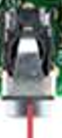

The **audio jack** on a Raspberry Pi provides a connection for headphones or speakers to output sound.

The DSI (Display Serial Interface) connector on a Raspberry Pi is used to connect official display screens and other compatible displays directly to the board. It allows the Raspberry Pi to transmit video and graphics data to the display using a high-speed interface. This connector simplifies connecting displays and ensures that the display can receive data efficiently, which helps in creating custom user interfaces or projects that require a visual output.



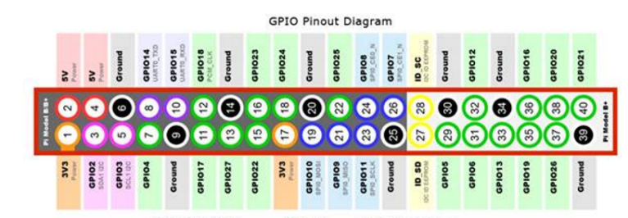

The GPIO (General Purpose Input/Output) headers on a Raspberry Pi allow you to connect a wide range of electronic components and control them through programming. You can use these pins to build custom projects like a home automation system, where you can control lights and appliances remotely. For example, you can use these pins to turn an LED light on and off by connecting it to the GPIO pins and writing a simple program. This makes it easy to create projects like a blinking light or a basic alarm system.

* **GPIO Pins (like GPIO 17, GPIO 18, etc.)**: Used for general input/output to control devices like LEDs, sensors, or buttons.
* **Power Pins (5V (Pins 2 and 4) and 3.3V(Pins 1 and 17))**: Provide power to components like motors or sensors.
* **Ground Pins (GND6, 9, 14, 20, 25, 30, 34, and 39)**: Complete the electrical circuit when connecting components.
* **PWM Pins (GPIO 18, GPIO 19)**: Used for tasks like controlling motor speed or dimming LEDs.
* **I-2C Pins (GPIO 2 - SDA, GPIO 3 - SCL)**: For connecting devices like temperature sensors or displays that use I-2C(integrated circuit) communication.

**How to use Raspberry PI as a beginner and what projects can be made?**

To use raspberry PI as a beginner we will first download the Raspberry Pi operating system in our micro-SD card. Then we insert the microSD card with a Raspbian operating system into the Raspberry Pi. Plug in the power adapter, keyboard, and mouse to the Raspberry Pi. After completing this you can connect your computer with the Raspberry Pi by connecting the HDMI cable. Turn on the Raspberry Pi by pressing the power button and you can use it for your project.

Raspberry Pi can be used to make a simple weather station. A DHT (Digital Temperature and Humidity Sensor) sensor will be used to collect temperature and humidity data, which will then be displayed or stored. Details of steps are on the next page.

Steps:

1. Connect: Attach the DHT sensor to your Raspberry Pi using a breadboard and jumper wires.
2. Code: Write a Python code to read temperature and humidity data from the sensor.
3. Run: Run the code to see the readings printed on your screen.
4. Output: Optionally, display the data on a screen or store it for later analysis.
5. Total Estimated Cost: Approximately PKR 8,500 to PKR 16,000.

**Question 2:**

Given below an Arduino module; Study its layout and write a detailed report on the mounted components and their functions.

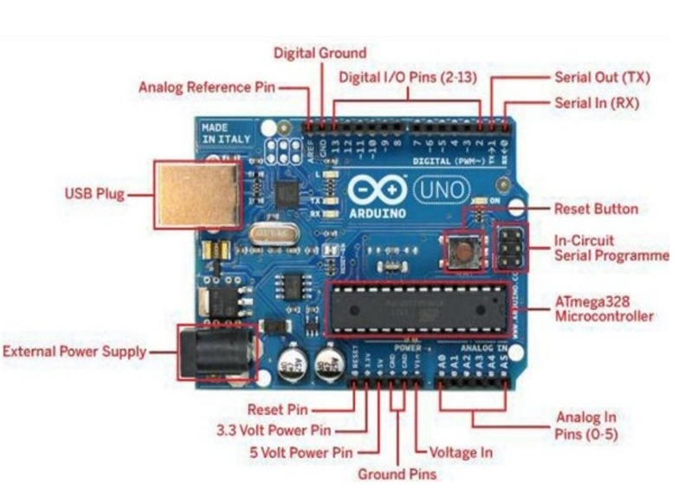

**The microcontroller is the heart of an Arduino board.** It's a tiny, programmable computer chip that executes instructions to control the board's functions. It reads input from sensors, processes the data, and sends output to actuators like LEDs or motors. The microcontroller's capabilities determine the Arduino's performance and the complexity of projects it can handle.

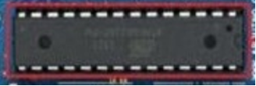

MICROCONTROLLER

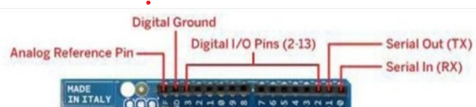

• **Digital I/O Pins:** These pins can be used to control digital signals (high or low voltage levels) to interact with components like LEDs, motors, and sensors.

• **Analog Reference Pins:** These pins can measure analog signals (varying voltage levels) from sensors like potentiometers, photoresistors, and microphones.

**• Serial In/out :** They send and receive information one bit at a time, like a conversation. You can use them to connect to computers, sensors, or other boards.

**• Digital Ground Pins:** These pins provide a common ground reference for the circuit, ensuring proper electrical flow.

* **Reset Pin:** Resets the microcontroller, restarting the Arduino.
* **3.3V Power Pin:** Provides 3.3 volts for low-power components.
* **5V Power Pin:** Provides 5 volts for powering various components.
* **Ground Pin:** Provides a common ground reference.
* **Voltage In Pin:** Allows for external power supply.
* **Analog In Pins:** Measures analog signals from sensors.

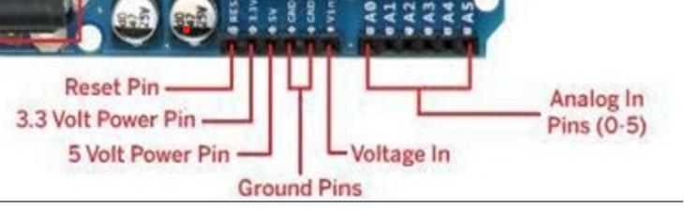

**External power supply** for Arduino boards lets you use a different power source than the one built into the board. This is helpful when you need more power for your project or want to use a battery. You can connect an external power supply to the "Voltage In" pin on the Arduino.



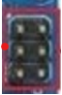

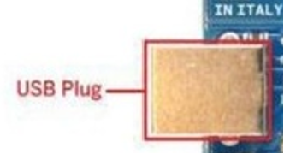

The USB plug on an Arduino board provides power and communication. It can power the board and connect it to a computer for programming and data transfer.

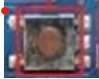

**The reset button on an Arduino board is used to restart the microcontroller.** Pressing this button will cause the Arduino to reset, clearing any previous data or program.

Reset Button

**How to make projects using Arduino?**

Gather your apparatus, Arduino board, breadboard, wires, and the parts you need for your project (like LEDs or sensors). Decide what you want to make and how it will work. Connect the circuit on the breadboard. Use the Arduino software and write your code C/C++ language to tell the board what to do. Connect your Arduino to your computer, upload the code, and see if it works.

**How is Arduino different to Raspberry Pi?**

The Raspberry Pi and Arduino are two boards, each used for a certain task. If Raspberry Pi can perform more complex activities like running apps or functioning as a small computer, Arduino is good at controlling things like motors or lights. Therefore, Arduino can be a better option if you want to create a robot or control a machine. But the Raspberry Pi is a good choice if you need a computer for home automation.

**Conclusion:**

Arduino is for projects involving electronics since it is fantastic at controlling hardware, such as robots, sensors, and motors. Because of its ease of use, you may learn the fundamentals of electronics, coding, and creating gadgets like Internet of Things (A device that is embedded with sensors and exchanges Input and output data using Internet) . However, the Raspberry Pi is more capable and can run a whole operating system, which makes it perfect for larger projects like media centers, home automation, or even learning how to program video games. With Raspberry Pi, students can experiment with computer science, programming, and even building their own tiny computers. While Raspberry Pi is a terrific tool for learning computer science and software development, Arduino is excellent for practical electronics projects. Both provide students with practical experience that fosters creativity and problem-solving abilities. In this lab we have learned how each device works and it’s benefits which will help us in future projects that we will build.